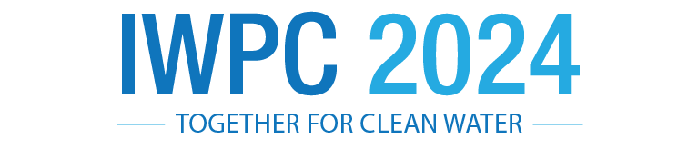

IWPC 2024 Call for Presentations

Submissions are now being accepted by the Illinois Wastewater Professionals Conference (IWPC) Program Committee for presentation at the 2024 Annual Conference to be held at the Embassy Suites Hotel & Conference Center, East Peoria, Illinois Monday, March 18 through Wednesday March 20, 2024. Submission deadline is Friday, September 15, 2023.

The technical program will cover all aspects of the water environment. Case studies on process improvements or completed projects are encouraged. The Program Committee is especially interested in the following topics:

* Research and Innovation Related to the Wastewater Industry
* Collection Systems Design, Modeling and Operation
* Laboratory Operations including methods and research, analysis, accreditation, and instrumentation.
* Nutrient Removal and Reuse including Planning, Permitting, Design, Technology and Operational

Considerations

* + PFAS o S2EBPR o N&P Removal
* Wastewater Treatment Plant Operations (Fundamental to Advanced)

|  |  |  |  |
| --- | --- | --- | --- |
| o | Planning, Design and Construction Case Studies | o | Liquid Treatment Processes |
| o | Biogas & Renewable Advanced Treatment | o | Solids Treatment Processes |
| o | Emerging Challenges | o | Anaerobic Digestion |
| o | Process Based Energy Strategies to Enhance Reliability | o | Aerobic Digestion |
| o | Biomass Intensification | o | Safety |
| o | Advanced Data Tools | o | Emergency Management |
| o | SCADA Installations/Improvements | o | Regulations |
| o | Internal Plant Training Programs | o | Disinfection |
| o | Activated Sludge Process Control | o | Wet Weather Flows |

* Pretreatment including Ordinances, Technologies and Compliance
* Storm Water and Wet Weather Management
* Sustainability & Energy o Sustainable Biosolids Management, focusing on Nutrient Removal and Energy o Wastewater Energy – Energy Efficiency Improvements; Net-zero plants; Energy/Resource Recovery o Green Infrastructure and Sustainable Design Practices Applied to Wastewater Facilities o Water Reuses
* Watershed Management
* Career Development/Leadership o Topics of interest for Young Professionals and Students o Leadership
  + Communications
  + Diversity Equality & Inclusion
* Other Subjects that are of Keen Interest to the Wastewater Industry

Presentations must be submitted through the online form at [Illinois Wastewater Professionals Conference (memberleap.com)](https://www.memberleap.com/members/form_edit.php?org_id=IWPC&fid=6486055) and should be 400 words or less. Note that this year we are not requiring what was previously referred to as “short abstracts” and “long abstracts,” and submissions of any length under 400 words which encompass the scope of the presentation are acceptable. For questions contact Sai Archana Kuchimanchi, IWPC Program Committee Chair at archana.kuchimanchi@rjnmail.com.

Selection is based on an evaluation of submittals by the IWPC Program Committee, considering quality, originality of subject, technical content, and significance to understanding and improving the water environment. Diversity is strongly valued as we believe it increases the value of the program and the overall event; all interested presenters, including young professionals are encouraged to apply. Presentations that are overtly marketing products or promote a single or proprietary technology will not be accepted for the Technical Program. Thank you in advance for your presentation submission!